SIMATS ENGINEERING
ASSESSMENT TOOL 2

COURSE NAME: Database Management Systems COURSE CODE: CSA0501

COURSE OUTCOME COVERED

CO1: Analyze DBMS architecture, different data models, schema types, and design ER/EER diagrams, relational schemas for case-based scenarios by identifying entities and relationships. (BL1, BL2)

Activity Tool : Concept Mapping (Medium) Assessment Tool Weightage: 35%

Dr

QUESTIONS Total Marks: 50
Q.No | Question | Bloom's Level | Marks
1 | Construct a concept map linking the following terms: DBMS, Schema, Instance, Data Model, ER Diagram, Entity, Attribute, Relationship. | BL2 – Understand | 5
2 | Create a concept map for the three-level ANSI/SPARC architecture showing data independence at each level. | BL2 – Understand | 5
3 | Map the relationship between file-based systems and database systems, highlighting the problems solved by DBMS. | BL2 – Understand | 5
4 | Design a concept map for ER diagram components: entity, weak entity, attribute types, relationship types, and participation constraints. | BL2 – Understand | 5
5 | Construct a concept map comparing Hierarchical, Network, and Relational data models with their key properties. | BL2 – Understand | 5
6 | Develop a concept map for the EER model showing how it extends the basic ER model with generalization, specialization, and aggregation. | BL2 – Understand | 5

7 | Create a visual concept map for the DBMS software architecture, illustrating the flow from user request to data retrieval. | BL2 – Understand | 5
8 | Map the data models discussed in CO1 to real-world applications and explain the suitability of each model. | BL2 – Understand | 5
9 | Construct a concept map for schemas and instances, showing how they relate to physical and logical data independence. | BL2 – Understand | 5
10 | Design a concept map for the roles and responsibilities in a DBMS environment: DBA, End User, Application Developer. | BL1 – Remember | 5

- ANSWER

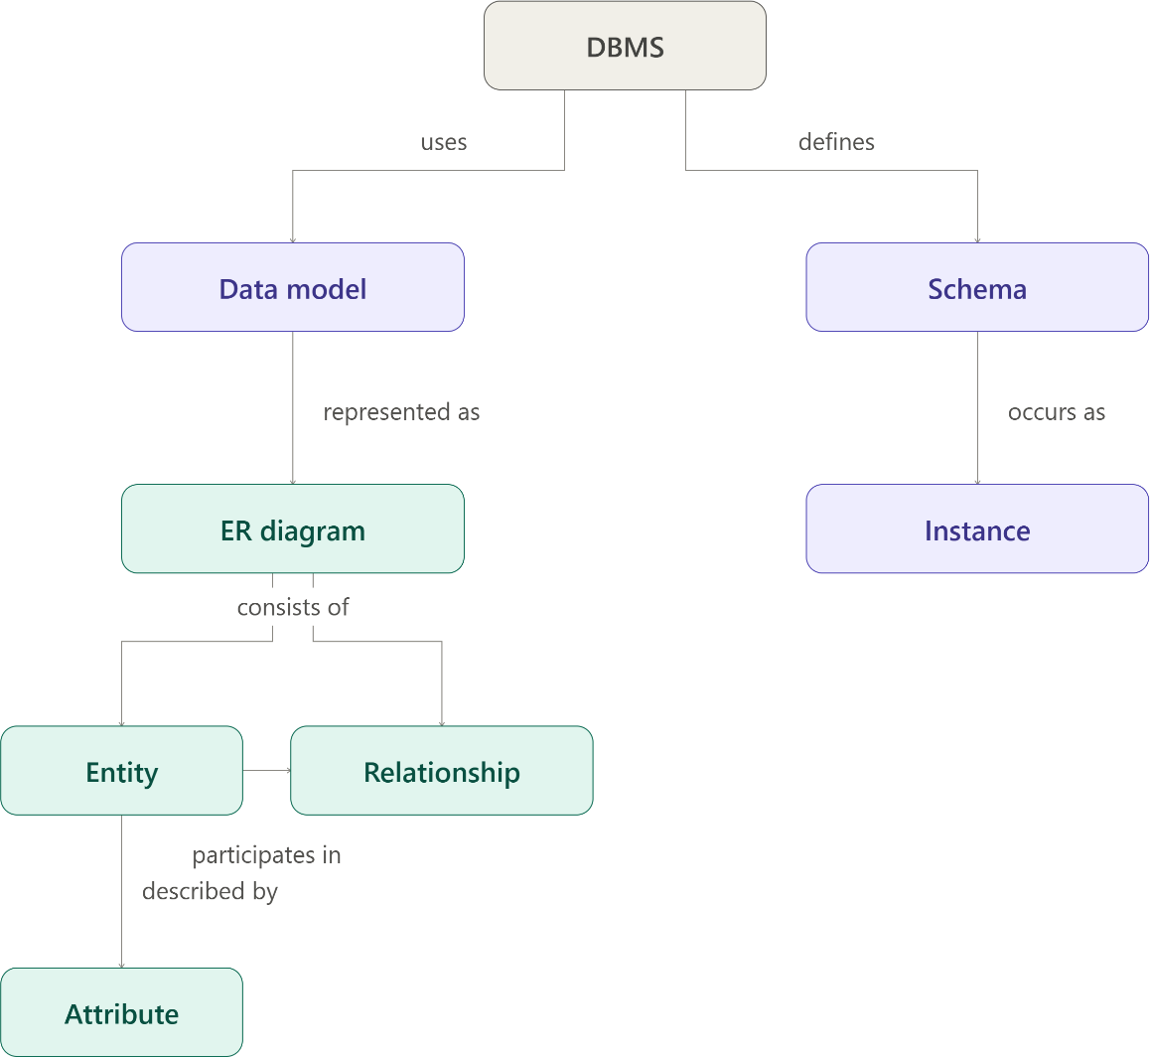

Here's the concept map linking all eight terms, built as propositions (concept → linking phrase → concept), the way CO1 asks you to trace relationships between data models, schemas, and ER components.
A quick walk-through of the logic behind it:

  - DBMS uses a Data Model to organize data conceptually, and DBMS defines the Schema, which is the overall logical structure of the database.
  - Data Model is represented as an ER diagram — the ER diagram is the concrete tool used to express a data model at the conceptual level.
  - Schema occurs as an Instance — the schema is the fixed design (like a blueprint), while an instance is the actual data present at a given moment in time.
  - ER diagram consists of Entity and Relationship — these are the two core building blocks of any ER diagram.
  - Entity is described by Attribute — attributes are the properties that characterize an entity (e.g., a Student entity described by name, roll number).
  - Entity participates in Relationship — relationships capture how two or more entities are associated (e.g., Student enrolls in Course).

ANSWER

This map reads top to bottom as one continuous chain, which is the cleanest way to show where each type of independence sits in the architecture:
  - Users access data through the External level — each user or application only sees the view relevant to them (subschemas).
  - External level enabled by Logical Data Independence, which shields it from changes to the Conceptual level — you can add a table, split an entity, or restructure the global schema, and existing user views keep working unchanged.
  - Conceptual level enabled by Physical Data Independence, which shields it from changes to the Internal level — you can change indexing, file organization, or storage devices without touching the conceptual schema or any application built on it.
  - Internal level maps onto the stored database — the actual bits and blocks on disk.

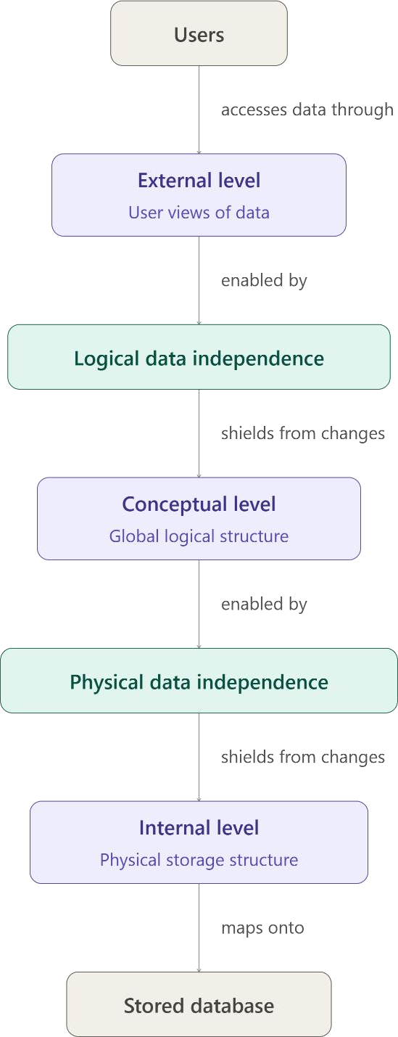

- ANSWER

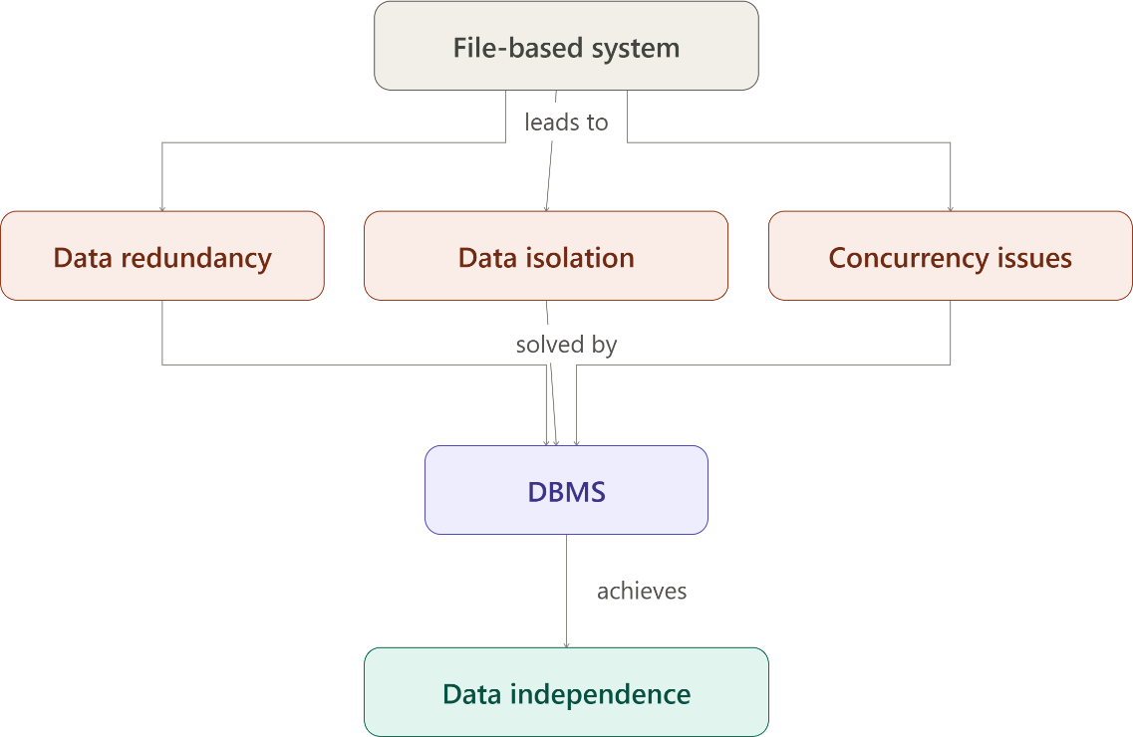

File-based systems vs database systems — this map shows the problems file-based systems create and how DBMS resolves each one, converging into the benefit of data independence.

- ANSWER

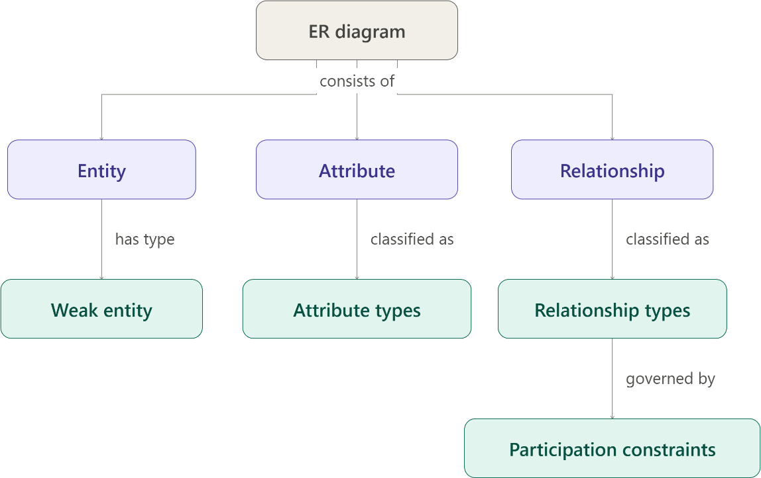

- ANSWER

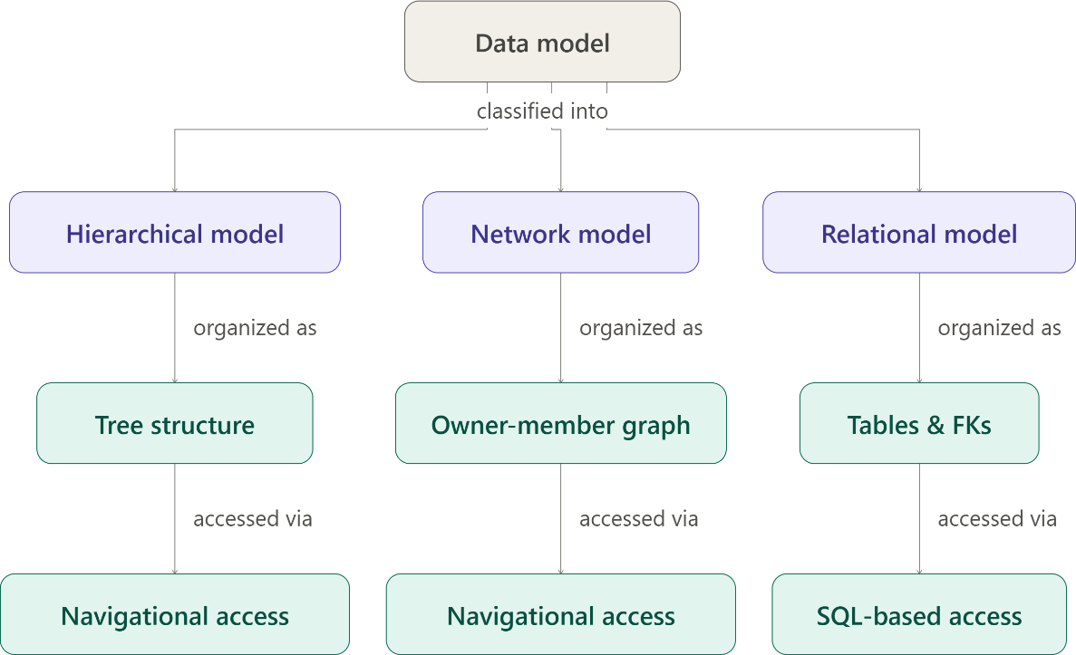

- ANSWER

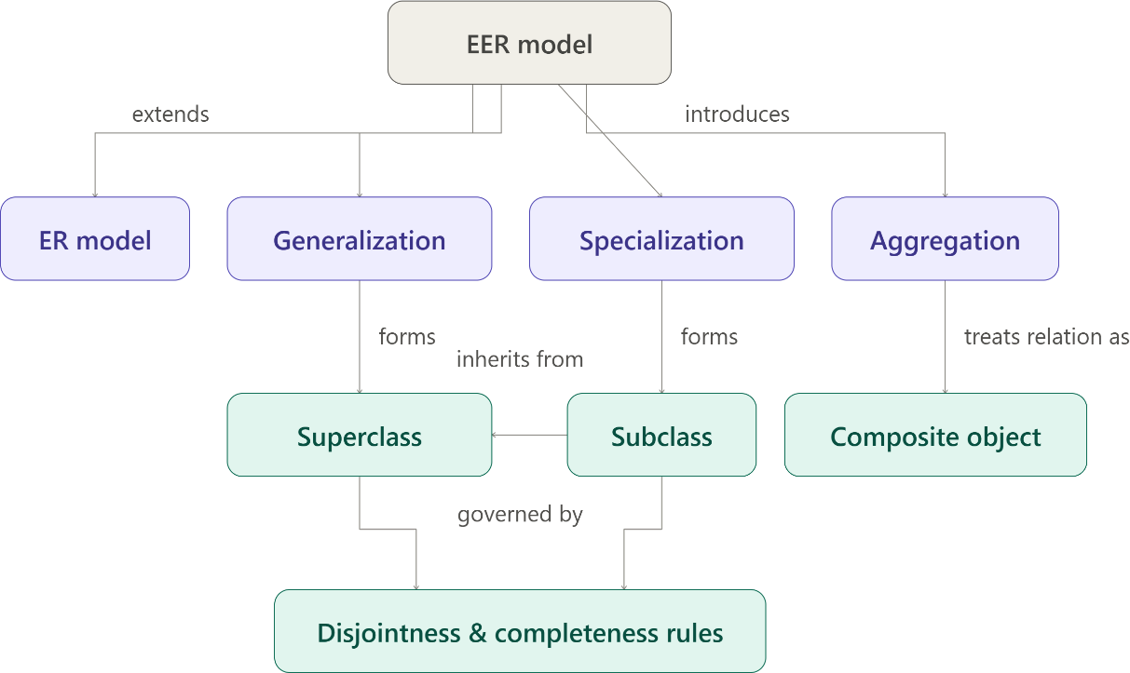

- ANSWER

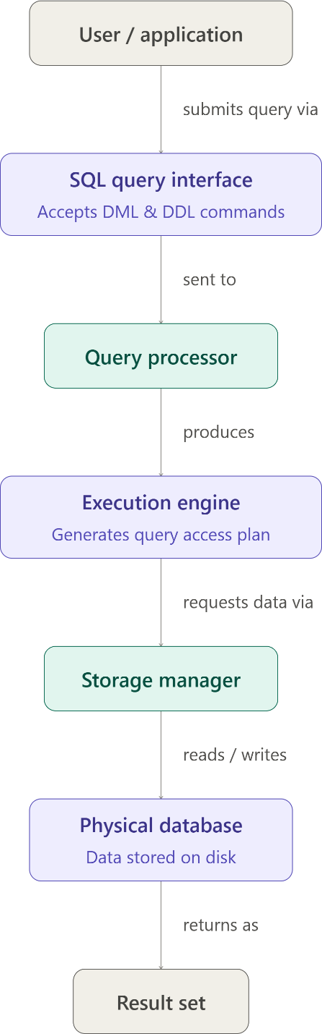

- ANSWER

Data models mapped to real-world applications and their suitability

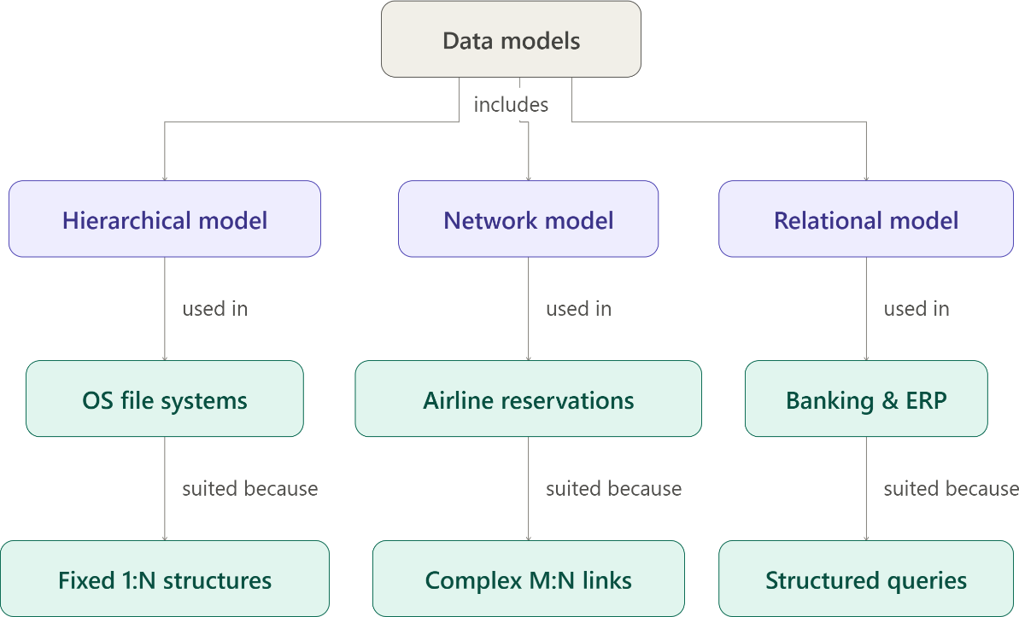

- ANSWER

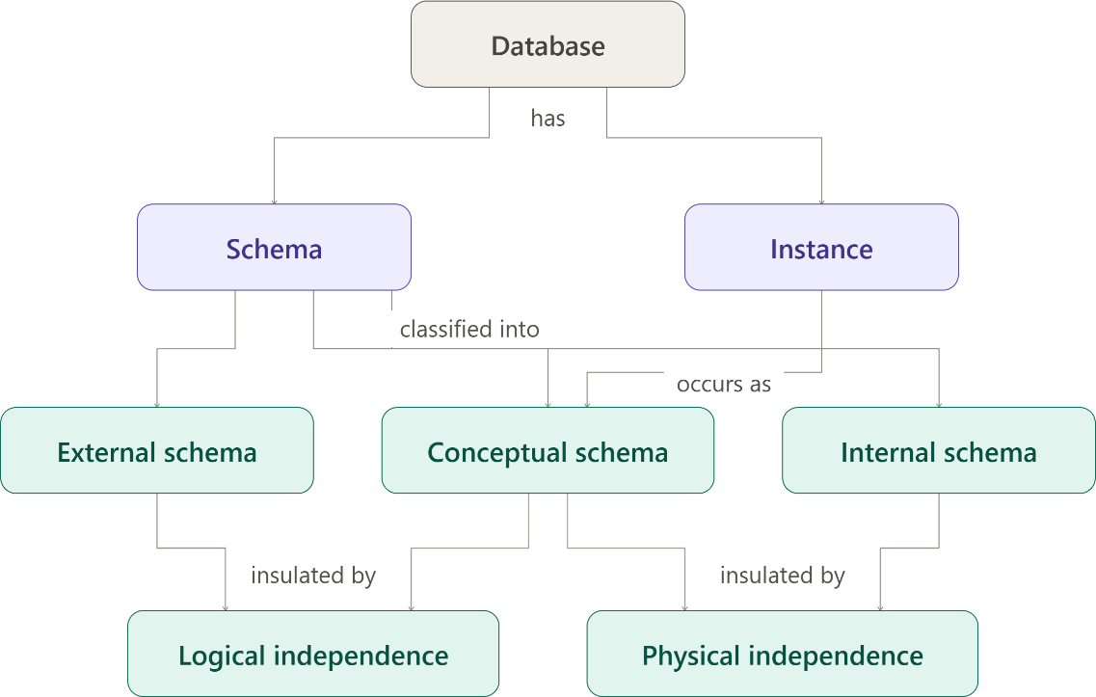

- ANSWER

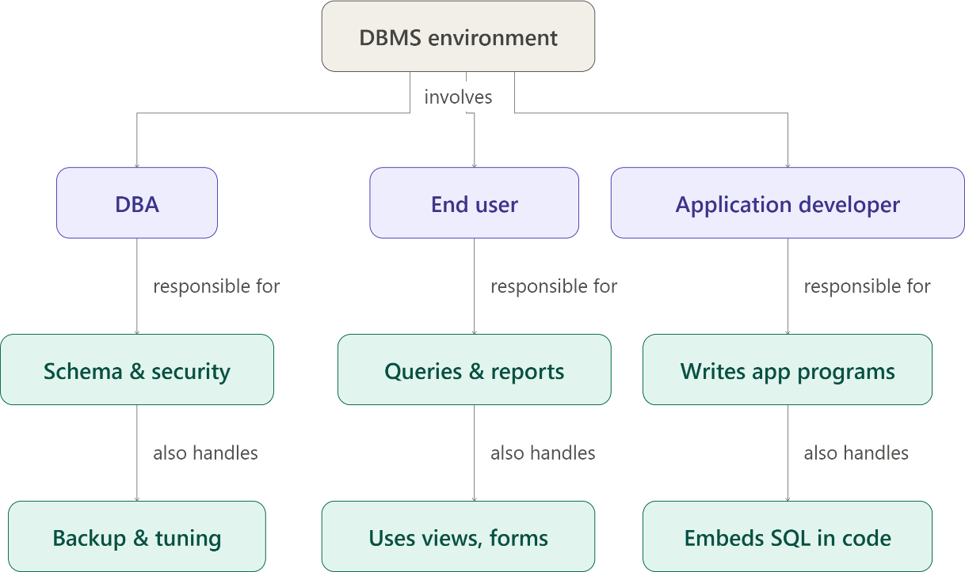

Code of Conduct:

I Pugalendhi M/192521325 (Name / Reg No) certify that this submission is my original work and that I have adhered to the guidelines specified for this assessment.
I understand that any violation of academic integrity rules will result in disciplinary action.

Signature of the student:

RUBRICS FOR CALCULATION:

Criteria | Weightage | Level 4 (Exemplary) | Level 3 (Proficient) | Level 2 (Developing) | Level 1 (Beginning)
Concept Identification | 25% | Identifies all key concepts from literature accurately and comprehensively | Identifies most key concepts with minor omissions | Identifies limited concepts; some are | Fails to identify essential concepts

 |  |  |  | irrelevant or missing
Linkages | 25% | Establishes clear, meaningful, and accurate relationships  between concepts | Shows correct relationships with minor gaps | Relationships are weak, unclear, or partially incorrect | No meaningful relationships established
Organization | 20% | Concepts are well-structured hierarchically  with logical flow and grouping | Mostly organized with minor  structural issues | Some organization but lacks  clear hierarchy | No logical organization or structure
Integration of Literature | 20% | Integrates multiple studies effectively to show connections and  comparisons | Shows some integration of literature | Limited integration; mostly isolated concepts | No integration of literature evidence
Clarity | 10% | Concept map is clear, neat, visually structured, and  easy to interpret | Generally clear with minor readability  issues | Clarity is reduced; difficult to interpret in  parts | Poorly presented and hard to understand

